Rescued From Babylon
“The Biblical significance of historical and mystical Babylon.”
Wade Burleson
IstoriaMinistries.Com


Last night, I told Rachelle (my wife), “I have an idea about a piece I want to write.”
“What is it?” she asked.
“Before I answer, I want you to be honest. Don’t be nice!”
We both laughed.
“What is it?” she asked again.
“I want to write about the Babylonian Captivity and how it pictures God’s salvation of us.”
There was a momentary pause, and then she said honestly, “I can’t wait to read it!” Maybe my wife affirmed the idea because she’s part of our women’s Istoria Bible study on Isaiah and has more context about Babylon than most.
“But, Wade,” Rachelle continued, “How will you entice people to read about the Babylonian Captivity of the Jews? That’s ancient history. Nobody cares!”
Rachelle knows reading about the Babylonian Captivity isn’t on your bucket list. It’s tough enough to get kids to school on time, balance the checkbook, and fulfill your work and home responsibilities.
If I could convince you to read and understand this post, I may give you more confidence about your future, help you trust in Jesus's faithfulness to care for you and your family, and possibly enable you to have internal peace about life and Christ’s transformational power at work in you.
When you understand Babylon in the Bible, you appreciate your salvation in the Savior.
Here’s a serious question for you:
“How can any of us escape our bondage to sin and addictions, overcome the manifold idolatries in our lives (work, pleasure, money, sex, etc.), die to our selfishness and pride, love others, live with purpose, enter into the Kingdom of Jesus, and receive eternal life?”
To be genuinely biblical with our answer, we can’t begin it with anything or anyone but God.
Answer: “God must rescue us from our captivity in Babylon!”
The theme of the Bible is God’s people being rescued from Babylon. The historical city of Babylon is a picture of mystery Babylon in every human heart.
Some Christians wrongly say, “I don’t have a great testimony about conversion to Christ.” That’s not true. Here is your story.

Babylon and the Bible

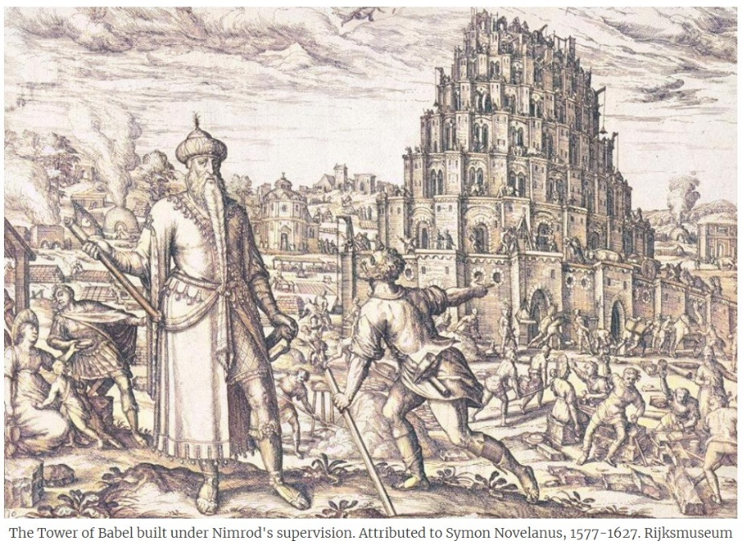
The Bible ends in the book of Revelation with the triumphant victory of Jesus, the Messiah, conquering the city of Babylon.

“After this, I saw another messenger coming down from heaven. He had great authority, and the earth was illuminated by his splendor.

With a mighty voice, he shouted: “‘Fallen! Fallen is Babylon the Great!’”

Revelation 18:1

Then, in Revelation 18:9
“Woe! Woe to you, great city, you mighty city of Babylon! In one hour, your doom has come!’
But wait! The historical city of Babylon was destroyed centuries before John wrote Revelation.
As we will see, historical Babylon is a “type,” “shadow,” or “picture” of mystery Babylon in Revelation.
Jesus, as the Messiah, attacks and conquers the tall walls of mystery Babylon in the hearts of His people.
Jesus brings Babylon down. The enclosed, walled-off place in your heart that is the seat of rebellion toward God is called “mystery Babylon” (Revelation 17:5).
The fall of mystery Babylon in Revelation 14-18 reveals God’s grace in our redemption and God’s power in our deliverance from our bondage to sin and death.
Mystery Babylon and its Fall is your story of deliverance by Christ. It’s my story, too.

To appreciate how the Messiah has saved us, we must comprehend Babylon in the Bible.
Principle #1: Salvation is our deliverance from sin by God’s work, not a work of ours.

Historical Babylon
Man’s sin was so blatant after Creation that God destroyed civilization with a flood. But even after this Divine judgment, men began coalescing in “cities built in the land of Shinar and Assyria” (Gen. 10:10-12).
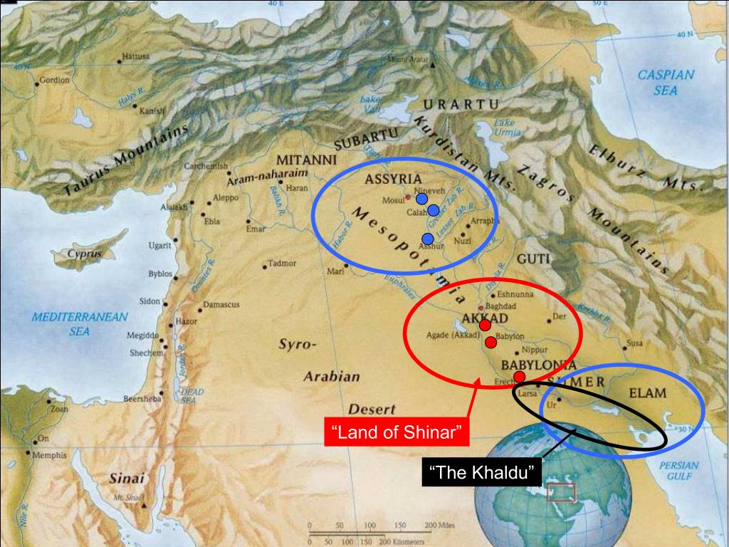
There are eight cities listed in Genesis 10:10-12. Babylon is the first city on the list of eight.
The historical city of Babylon epitomizes man’s rebellion against God throughout history. Babylon symbolizes that man is, by nature, a rebel against God.
God told Noah and his sons to spread and fill the earth (Genesis 9:1), but soon, the descendants of Noah began rebelling against God’s command and built themselves cities.
One could go so far as to say cities of men throughout history have been the focal points of man’s rebellion against God. Have you ever noticed the crime rate in cities? Are you reading the newspapers in 2024 about wealthy people in Paris, Madrid, San Francisco, New York, and other cities around the world being targeted for crime?
You may not realize it, but Thomas Jefferson argued for an agricultural nation of small townships and a restraint on building massive cities in the United States. Following the philosophy of John Locke, Jefferson believed that where large cities are built, there is a concentration of power and a contagion of evil that harms a nation.
As an aside, “flyover country” in the United States contains “God-fearing” people who keep the Creator’s commandments (Natural Law), but cities in the United States are filled with crime, anarchy, and evil. A nation is controlled by its great cities. If you live in a “big city,” you’re not necessarily called to leave; just be aware that people with hearts of rebellion come together to consolidate their power.
Nations controlled by Babylon (rebellion against God) become so comical that reading the Babylon Bee (newspaper) becomes a lesion in merging total absurdity with today’s reality to form a tragic comedy.
Babylon is the first city mentioned after Noah’s flood.
In violation of God’s commandment, Noah’s great-grandson, Nimrod, began a prolific building campaign. Nimrod is credited with building all eight cities listed in Genesis 10:10-12, including Babylon.
The eight cities of Genesis represent man’s rebellion throughout history, just as the seven churches of Revelation represent man’s service to God throughout history.
Shinar, possibly in tribute to the “mighty Nimrod.”
Here’s the significance of Nimrod and the early eight cities:
- Nimrod in Hebrew means “let us rebel,” from the root מ.ר.ד, which means “rebel.”
- Nimrod establishes each city, though the cities are from different times and ages.
- Nimrod, like Pharoah (Egypt), Augustus (Rome), and Czar (Russia), became a title.
- Nimrod, according to Jews, Christians, and Muslims, built “The Tower of Babel.”
- Nimrod sources man’s confusion, for rebellion leads to Babel (Heb. “confusion”).
- Nimrod and his city of Babylon in the Bible are both historical and mystical.

After reading so far, it might be easy to point the finger at cities, civilizations, and Caesars and say, “They are the problem!” But we must never forget something vital to our understanding of the Bible.

Every human heart without Christ has Babylon as its capital.
Principle #2: Rebellion in our hearts against God can only be removed by the King Redeemer.

The Babylonian Empire
Sumer is the name secular historians give the region where the city of Babylon was located. It is called Shinar in Genesis 10. This region had many different “Nimrods” (kings) that ruled their city-states or tribes (families).
The Sumerian civilization of Genesis 10 is the oldest in recorded human history.
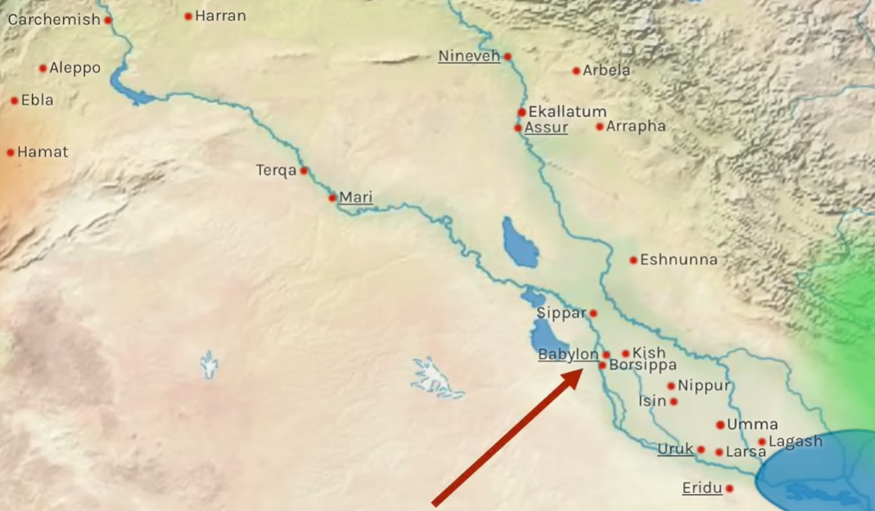

Shinar was the region between the Euphrates (the river on the left) and the Tigris, the river on the right). To the north, the massive valley was a desert.
The city of Babylon was built on both sides of the Euphrates River, which ran underneath the city’s outer walls and beneath its main gates.
Babylon was a port city, with traffic going up the Euphrates from what we call the Persian Gulf.

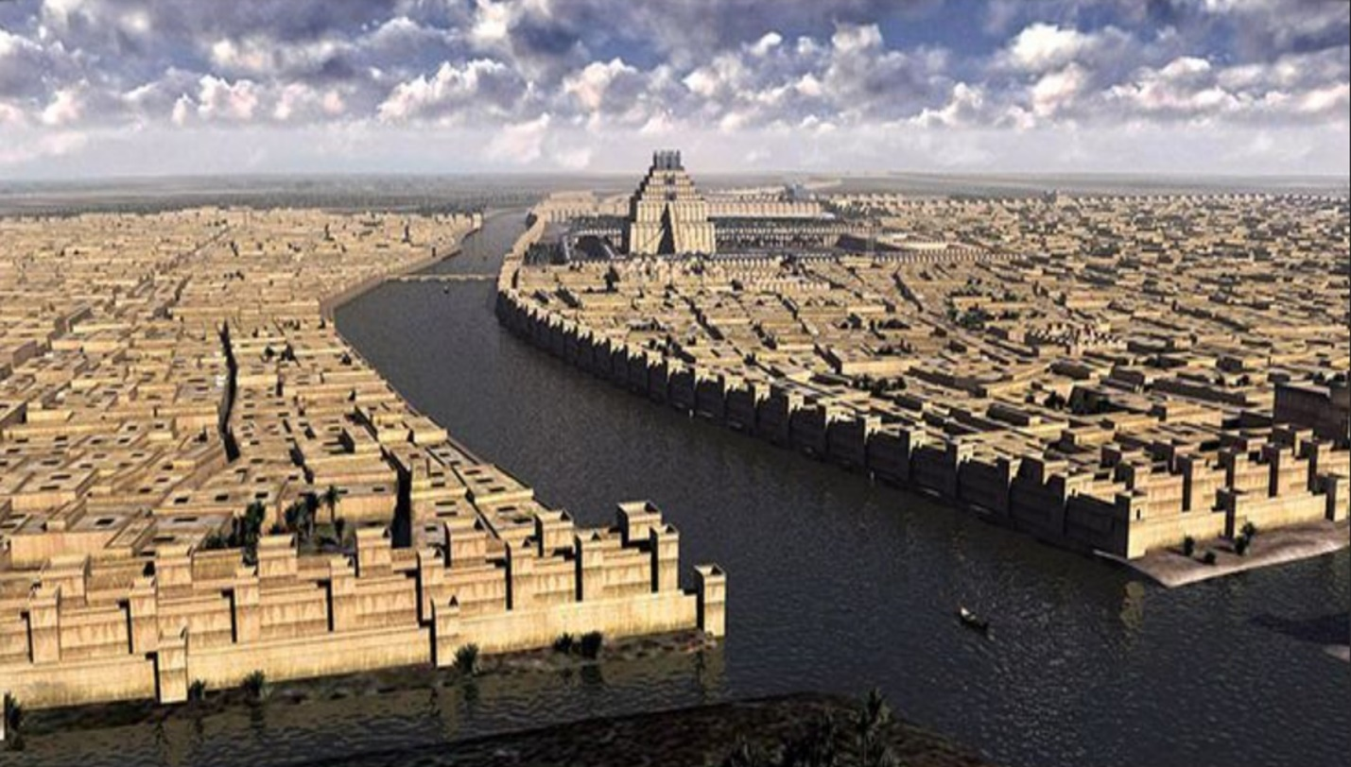
The city-states of Sumerian kings, including Babylon, eventually merged into one kingdom called Assyria. Noah’s grandson, Ashur (son of Shem), had founded the city of Ashur (Gen. 10:22) in Sumer. The kings of Sumer united, and the Assyrian Kingdom made Babylon the capital of the united Assyrian kingdom (est. 2100 BC to 911 BC).
A kingdom is “a king” ruling over a people and land, both of which comprise his “dominion”—thus, “king-dom.”
Some of the great Assyrian kings included Sargon and Hammurabi. It ultimately evolved into the world's first and oldest recorded empire, the Assyrian Empire (911-609 BC), which ruled the known world.
An empire emerges when a king uses his army to invade other kingdoms, conquering people and rulers and charging them a tribute or “tax” that is sent back to the empire's capital city.
The world’s first five empires go in this order:
Assyria (911 BC - 609 BC)
Babylon (609 BC - 539 BC)
Persia (539 BC – 333 BC)
Greece (333 BC – 146 BC)
Rome (146 BC-AD 410)
Please, don’t get bored; the good stuff is coming!
The prophet Daniel foresaw that during the days of the Roman Empire, an eternal King of kings (e.g., “the Rock not hewn with human hands that comes from heaven” in Daniel 2:45) would establish an “unshakeable Kingdom” over mankind (see Daniel 2, Daniel 9, and Daniel 11).
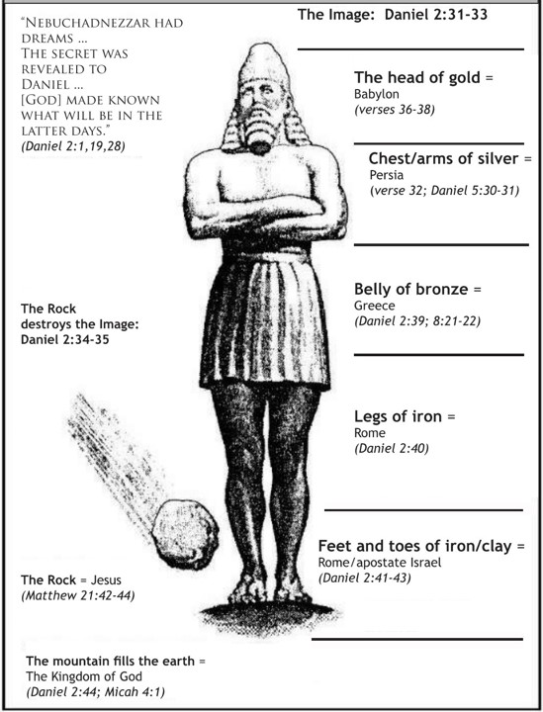
Of course, that King is King Yeshua, Jesus the Christ (Anointed One). From Him, “We have received a Kingdom which cannot be shaken, so let us show gratitude” (Hebrews 12:28).
If you think Christ’s Kingdom is not yet here on earth, then you have missed the entire teaching of the prophets. The Kingdom of Christ is here, right now. The question for you is: “How do I become part of His King-dom)?”
The King must deliver you. There’s little you can do except your cries for help. Everything else is up to the King, who has the power to free you from your bondage in Babylon.
Principle #3: Christ’s Kingdom is now all around us, and He is moving to conquer sinners.

Historical Babylon Rules the World for 70 Years
Let’s go back to Assyria, the world’s first empire.
The Assyrian empire ended in 609 BC at the Battle of Harran. Nabopolassar, leader of the largest tribe (family) in the ancient city, a people called “The Chaldeans,” destroyed the Assyrian army.
The world’s second empire, Babylon, with its roots as the first city mentioned in Genesis 10, destroyed the mighty Assyrian Empire at Harran. Where did Babylon get its army? Men from the most prominent tribe (family) of Babylon, the Chaldeans, became the mighty army of Babylon. This is why sometimes the Bible interchanges the word Chaledean with Babylonian (see Habakkuk 1:6).
So in 609 BC, Babel, the original symbol of humanity’s rebellion against God (Babylon), came to power and sought to dominate the world.
Four years later, in 605 BC, Nabopolassar died, and his son, Nebuchadnezzar, assumed the throne of the Babylonian Empire. The newly installed king took the Jewish princes Daniel, Hananiah, Mishael, and Azariah, better known by their Babylonian names Belteshazzar, Shadrack, Meshach, and Abednego, to his palace in Babylon as his servants (see Daniel 1).
Babylon was not some “hick” city or “backward empire.”
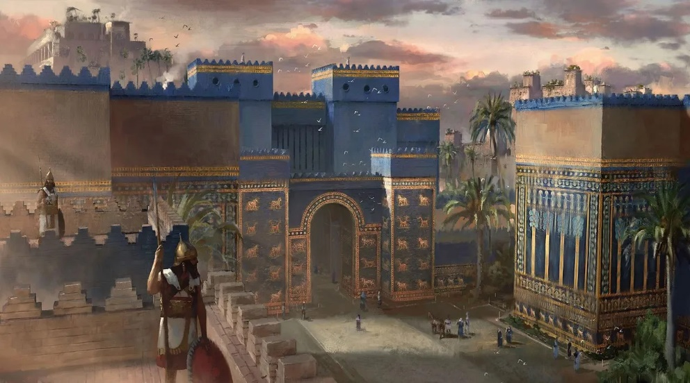
The Ishtar Gate, the northern gate to the city of Babylon, can now be seen on display at the Pergamon Museum in Berlin, Germany.
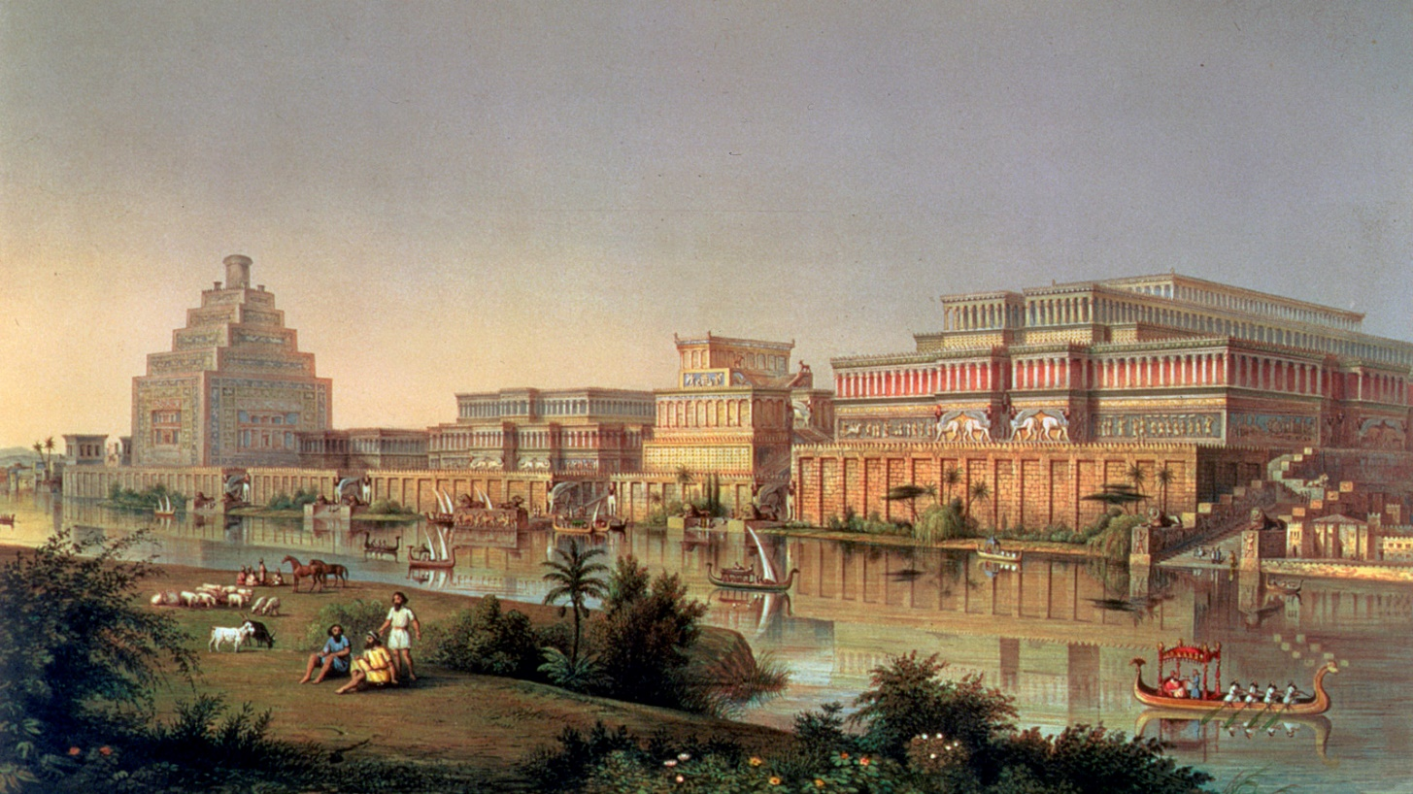
The ancient city of Babylon, capital of the Babylonian Empire (609 to 539 BC), rivals any city in beauty.
The most brilliant scientists, engineers, doctors, architects, and builders constructed what would have been our day's Shanghai or New York City. Two of the great wonders of the ancient world, the Hanging Gardens of Babylon and the Walls of Babylon that protected the city,
The chief gods of Babylon were Marduk, the chief god (later called Bel or Baal), and Marduk’s son, Nabu. Babylon's citizens often attached their god's name to their names, as in Nebu-chadnezzar and Belteshazzar.
Babylon, the epitome of rebellion against the One True God, was known for its luxury, scientific advancements, immorality, and worship of its stone, silver, and gold idols.
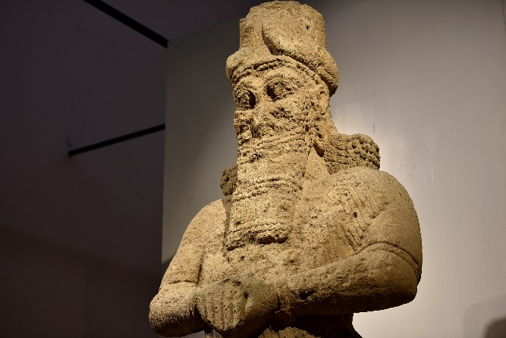
Colossal stone statue of the god Nabu. Statues like this were placed all around the city of Babylon, and citizens would keep smaller idols in their homes.
In 597 BC, King Nebuchadnezzar of Babylon returned to Jerusalem. He took another 10,000 Jews, the best workmen and skilled laborers, back to Babylon. He captured Judah’s king, Jehoachin, and took him to Babylon as a captive. Nebuchadnezzar, king of Babylon, replaced Jehoachin with Zedekiah (597-586 BC), the man who would be the last king of Judah.
These 597 BC Jewish captives dragged to Babylon included the prophet Ezekiel. While in Babylon, Ezekiel receives “visions from YHWH (God),” and he acts out (pantomimes) the “prophesies” of the future, sending short, written scrolls of warning back to Jerusalem, predicting Babylon's impending destruction of Zion (Jerusalem).
Jerusalem and the Temple, Ezekiel warns in his prophecies, will be destroyed by Babylon because of the rebellion, sin, violence, and injustice in the nation of Judah. The hearts of the people were rebellious, however, and they imprisoned and stoned the prophets who agreed with Ezekiel (and Jeremiah) and promoted the false prophets who “tickled the Jews’ ears” by proclaiming:
“‘Peace,’ when there is no peace. When a flimsy wall is built, they cover it with whitewash” - Ezekiel 13:10
Principle #4: The Truth in God’s Word may be ignored, but it will always come to pass.

The Destruction of Jerusalem and the Temple
In August 586 BC, Nebuchadnezzar, king of Babylon, in fulfillment of Ezekiel’s, Isaiah’s, and Jeremiah’s visions, returned to Jerusalem and destroyed the City of Jerusalem (Zion), tore down the Temple of God (YHWH), and carried God’s people (the Jews) into Babylonian Captivity. The destruction of Jerusalem and YHWH’s Temple by Babylonian soldiers came in August 586 BC, a date that continues to this day as a mourning “holy day” (holiday) in Israel (Tish B’Av).
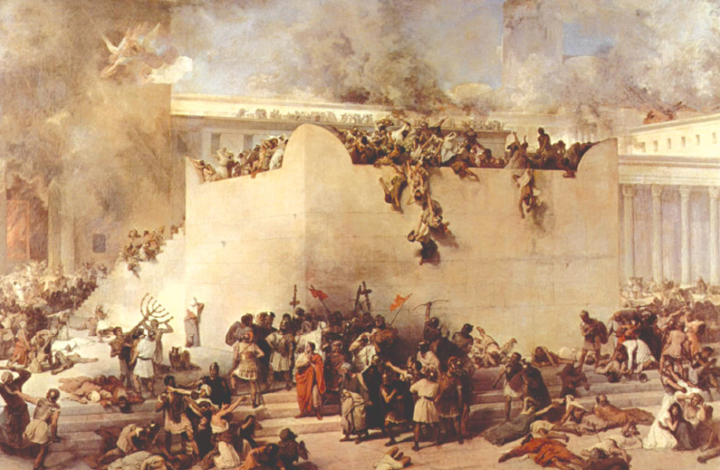
Jerusalem and the Temple of YHWH are destroyed by the Babylonian army in August of 586 BC.
Zedekiah, king of Judah, tried to escape the Babylonian assault by slipping through a breach in Jerusalem’s walls with his wife and sons. The Babylonian soldiers caught Zedekiah and his family near Jericho. Here’s what happened next:
“The Babylonians captured Zedekiah and marched him off to the king of Babylon at Riblah in Hamath. The king of Babylon then killed Zedekiah’s sons right before his eyes. The murder of his sons was the last thing Zedekiah saw, for they then blinded him. The king of Babylon followed that up by killing all the officials of Judah. Securely handcuffed, Zedekiah was hauled off to Babylon. The king of Babylon threw him in prison, where he stayed until the day he died.” - Jeremiah 52:9-11, The Message.

Conversion First Begins with Fear and Bondage
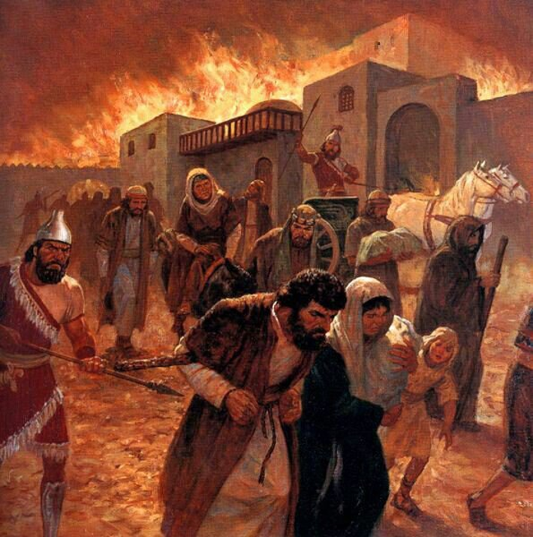
The walking trip from Jerusalem to Babylon takes 120 days. It is a harsh, arduous journey of 900 miles.
The number 120 in the Bible represents the transition from the age of the flesh to the age of the Spirit.
The number 120 appears throughout the Bible, such as at the upper limit of a man’s physical life in Gen. 6:3 and the 120 disciples in the Upper Room waiting for the Spirit to begin New Life.
It is understanding the spiritual symbolism of the number 120 shows that the cruel journey into bondage is the beginning of conversion in Christ’s people.
The Spirit’s first work of conversion is the fear that comes with the discovery that rebellion toward God brings bondage, captivity, and destruction.
The Apostle Paul reminds us of the two-fold work of the Spirit:
- Conviction of sin by fear.
- Conversion from sin by adoption.
“The Spirit you received does not make you slaves to fear again; rather, the Spirit you received brought about your adoption to sonship. And by Him we cry, “Abba, Father.” - Romans 8:15
Sadly, too many who proclaim Jesus to a lost world skip the fear of sin and go to the adoption of conversion. A growing sense of one’s bondage and captivity to sin’s destruction is the first step in bringing God’s people into the Kingdom of Christ.

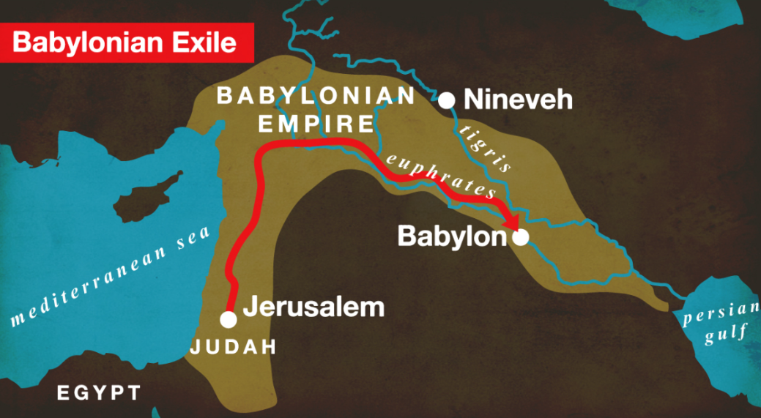
Next time you’re tempted to bail out a loved one from jail, maybe you’ll wait for the Spirit to accomplish His first work required for tearing down Babylon’s walls. The 120-day walk to Babylon provoked fear.
Principle #5: The Spirit’s work of "conviction” by fear is necessary for “conversion” by grace.

Hope Rising
When the Spirit’s first work of fear appears, hope from heaven begins to emerge. The captive Jews in 586 BC were the third group to make this trip into the Babylonian Exile (605 BC, 597 BC, and 586 BC). As they descended south in the desert valley between two rivers, the Babylonian soldiers pointed out the “dry bones” of their loved ones who never made it to Babylon. The pagans’ mockery must have only added to their fear, but the Jews must have remembered the words of Ezekiel’s scroll:

And God said to Ezekiel, “Son of man, can these bones live?” So Ezekiel answered, “O Lord God, You know.” Again, He said to Ezekiel, “Prophesy to these bones, and say to them:
‘O dry bones, hear the word of the Lord!
The LORD God says to these bones: “I will cause breath to enter into you, and you shall live. I will put sinews on you and bring flesh upon you, cover you with skin and put breath in you; and you shall live. Then you shall know that I am the Lord.’” - Ezekiel 37:3-6
God sometimes allows His people before conversion to continue in their willful sins that the power and grace of their deliverance is from Him and not of their works, lest any of us should boast.
The Jews who saw the dry, dead bones realized that only God can make the dead live.
As Ravi Zacharias used to say:
“Sin will take you farther than you want to go, keep you longer than you want to stay, and cost you more than you want to pay.”
But God…
The salvation of Nebuchadnezzar, king of Babylon, illustrates the principle of spiritually dead men being spiritually made alive by God’s grace.
Nebuchadnezzar was a brutal man—a true brute.
As we’ve seen, he murdered Jewish king Zedekiah’s boys, gouged out Zedekiah’s eyes, and dragged thousands of Jews and other ethnic groups into Babylonian Captivity.
He was a fornicator, an idolator, a boaster, a rebel against Nature’s God and Nature’s Laws (the 10 Commandments), and produced children who were even more wicked than he when they assumed the throne.
But God saved Nebuchadnezzar. The story of Nebuchadnezzar’s conversion, King of Babylon, is written by him in Aramaic and is found in Daniel 4.
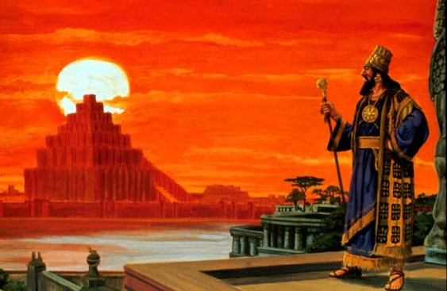
In 571 BC, about a decade before Nebuchadnezzar died, he stood on the roof of his palace, gazing at the Hanging Gardens he had built for his wife and the ziggurats he had constructed for Marduk and Nabu and reflecting with pride on “all I have built,”
The Spirit of God gave Nebuchadnezzar madness. He began to eat grass like a cow. His fingernails grew long, his hair grew long, and he walked around the palace like a naked madman.


The LORD attacked Nebuchadnezzar's walled-off heart to humble him. As the LORD always does when He conquers His people's fortified walls of pride, God succeeded in humbling Nebuchadnezzar. For seven years, Nebuchadnezzar was a madman, and the fear of his sin and bondage to it was rampant.
But in the end, the Spirit of God adopted Nebuchadnezzar into the eternal Kingdom of the one true God. Today, scientists and doctors call Nebuchadnezzar’s disease boanthropy, and it still exists in some people worldwide.
Principle #6: Pray for God to save those you love, for nobody is beyond God’s reach.

Historical Babylon Comes to An End

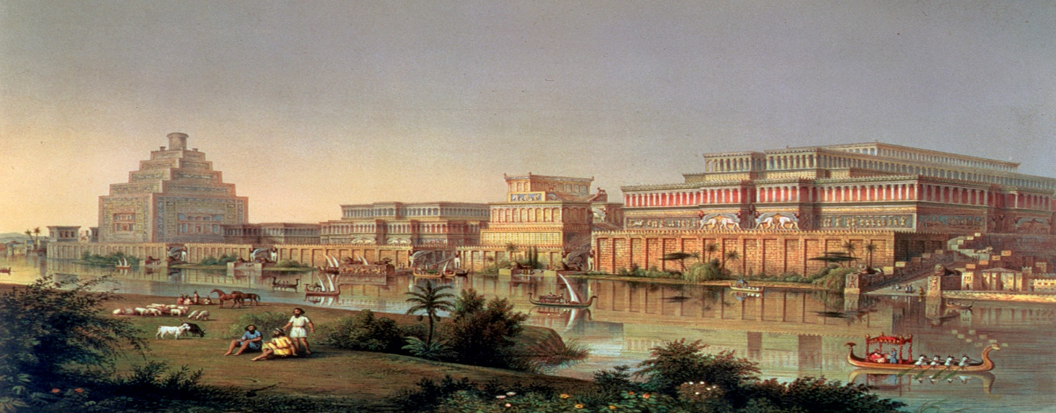
Now, the Good News.
The Babylonian Kingdom lasted only 70 years (609 - 539 BC)
Let me repeat that statement, for it’s crucial to understand how God defeats mystery Babylon (rebellion) in every sinner’s heart.
The historical Babylonian Kingdom lasted only 70 Years (609-539 BC). The Jew’s rebellion against God led them to blindness, brokenness, and Babylonian bondage.
After 70 years, the Exile ended because Babylon was defeated - forever.
Seventy has a sacred meaning in Scripture.
After reading God’s Law to the people, Moses took 70 elders to Mount Sinai for a special meal with God (Exodus 24:9 -11). Those 70 elders ministered to the new nation of Israel (Numbers 11:16).
Seventy speaks of comfort and peace with God through obedience to His instruction.
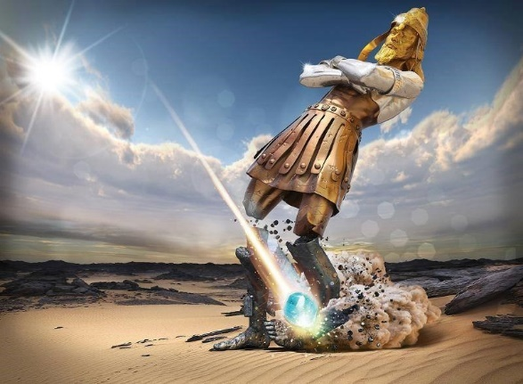
Most importantly, God revealed to Daniel that it would be 70 x 7 years before the Messiah established His Kingdom by putting an “end” to sin and establish His eternal Kingdom. (Daniel 9:24-25)
Six, especially 666, symbolizes man’s rebellion against God and His Law.
Seventy is the number of God’s salvation and deliverance of His people.
Many make the error of saying the Jews' “Babylonian Captivity” lasted for 70 years. But that is not what the Bible teaches. Jeremiah, the prophet, was explicit in his prophecy the Babylonian Kingdom, not the Exile, would last 70 years (609-539 BC).
“Nations will serve the king of Babylon seventy years. But when the seventy years are fulfilled (of nations serving Babylon), I will punish the king of Babylon and his nation, the land of the Babylonians, for their guilt,” declares the Lord, “and will make it desolate forever.” - Jeremiah 25:11-12
Babylon was the fortress city of rebellion against God. God brought it down in 539 BC.
Principle #7: When God moves to conquer Babylon in a sinner’s heart, He is always victorious.

How Did Historical Babylon Fall?

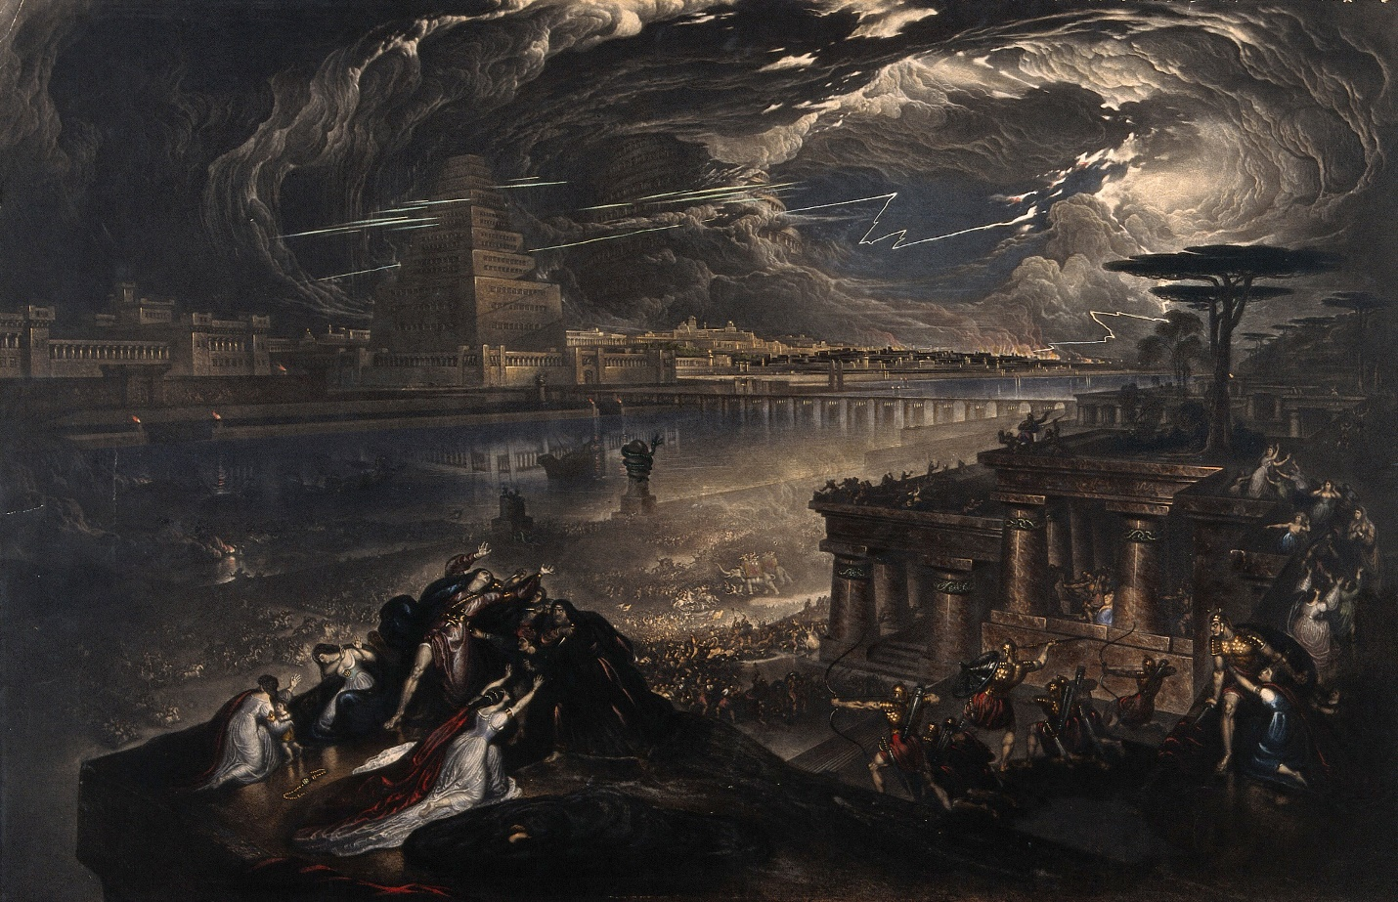
God used two things to bring down historical Babylon in October 539 BC.:
- His Messiah.
- His Finger.
First, let’s talk about Cyrus, King of Persia. In Isaiah 45:1, the LORD calls Cyrus “My messiah.” That bothers some Christians who don’t understand that “messiah” is a title that means “anointed one.” The translation of the Hebrew word for Messiah מָשִׁיחַ in Greek is the title Christ. Jesus is the eternal “Anointed One,” the King over all kings.
But God had deliverers in the Hebrew Scriptures who were “types” of Jesus. King Cyrus of Persia was one of those messiahs chosen to deliver God’s people.
“This is what the LORD says to His messiah (anointed one) to Cyrus, whose right hand I take hold of to subdue nations before him and to strip kings of their armor, to open doors before him so that gates will not be shut” - Isaiah 45:1
Belshazzar, king of Babylon and the grandson of Nebuchadnezzar was in the fortified palace of Babylon with his leading princes and soldiers for a 30-day feast of drunkenness and immorality.
While Babylon's leaders drank themselves into a stupor, Cyrus and his army from Persia (modern-day Iran) diverted the Euphrates River upstream, marched on a dry riverbed, and crawled under the mighty walls of Babylon, taking it down in one night.
Historical Babylon fell in one hour without firing a shot. Only King Belshazzar died that night, pierced with a sword by a Persian soldier. The Persian Empire began.
In the same manner as Cyrus took down historical Babylon, Jesus destroys mystical Babylon in the hearts of His people by invading the palace of our Babylonian hearts.
As Jesus went around Galilee and Judah healing people, the religious Pharisees accused Him of having His power from Satan. That’s why “the demons listen to You.”
Jesus responded:
“If Satan opposes himself and is divided, he cannot stand; his end has come. In fact, no one can enter a strong man’s house without first tying him up. Then he can plunder the strong man’s house. Truly, I tell you, people can be forgiven all their sins and every slander they utter.” Mark 3:24-26
Principle #8: Ground and center your Christian life on Jesus and His power, not your own.

The Finger of God at Babylon
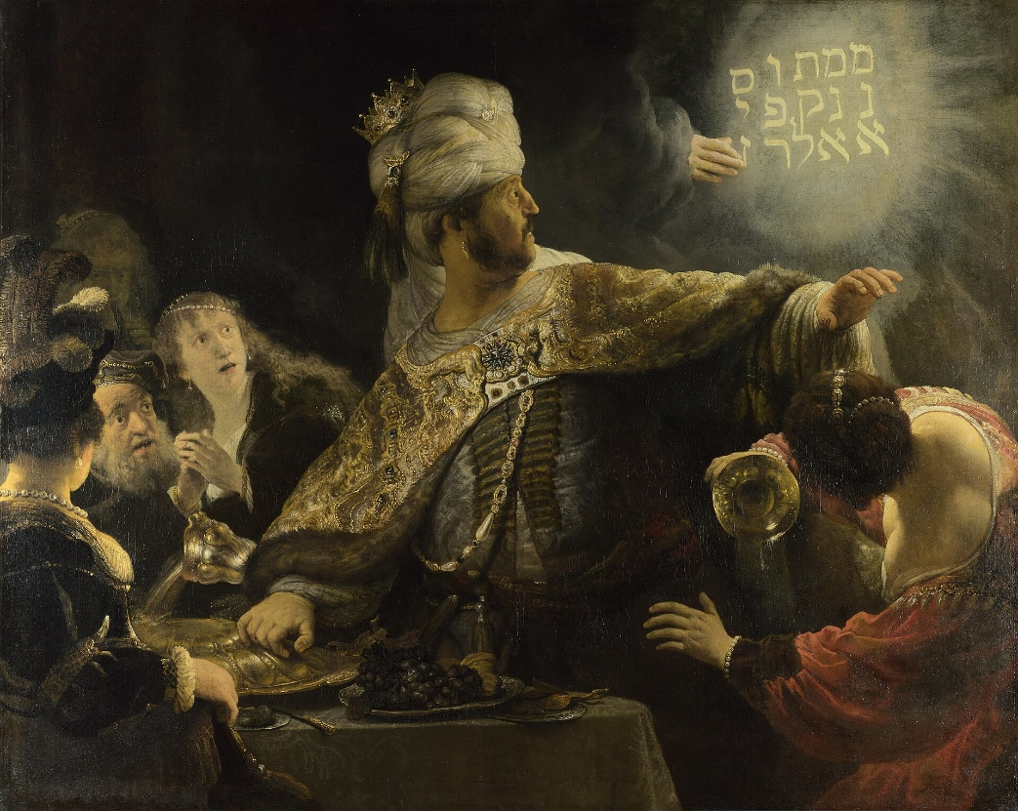
Rembrandt’s classic painting of Belshazzar’s Feast (AD 1636)
Belshazzar, King of Babylon, and the grandson of Nebuchadnezzar, was a wicked ruler who mocked the Highest God, drank himself into a stupor with wine using the stolen vessels from God's Temple in Jerusalem, and gave no thought to the meeting he would one day have with His Creator.
During October of 539 BC, Belshazzar hosted a feast in the Palace Hall of Babylon, during which a hand appeared and wrote on the wall these four Aramaic words:
Mene, Mene, Tekel, Upharsin
These four words mean:
"Measured, Measured, Weighed, Wanting."
King Belshazzar wondered what these words meant. He called Daniel, the magi from Jerusalem, to interpret. Daniel took notice of the Hand and the Handwriting and concluded:
(1). It was God’s Handwriting.
Daniel 5:5 says the Hand appeared "opposite the candlestick of the Temple.” The candlestick, stolen from Jerusalem by the Babylonians in 586 BC, was giving its light in Belshazzar's Palace and cast a glow toward the wall where the Hand wrote the four words.
It was Divine Handwriting. The presence of the Most High was in Belshazzar's Palace, Babylon.
Contrary to what others might say, "What happens in ____ does not stay in _______," God was in Belshazzar's palace, measuring, weighing, and bringing Belshazzar to holy judgment for a deficient, wasted, and ungodly life.
Jesus said, "Everyone will have to give account on the day of judgment for every empty word they have spoken" (Matthew 12:36).
If one gives an account for every idle word, how do some think there will be no accounting for every evil deed? There will be a reckoning with God God. He will "measure" one's life exhaustively, accurately, and personally.
Belshazzar's day of reckoning before the Most High God had come.
(2). The Shadow of God’s Justice Hung on the Wall

There was another light in King Belshazzar's Palace that night.
That light cast a shadow from the candlestick onto the wall where the words "Mene, Mene, Tekel, Upharsin" were written.
The shadow of the Temple candlestick (Menorah) would look like an old-fashioned scale (i.e., "the scale of justice"). It was quickly apparent to Belshazzar that the Divine Spirit was carefully measuring out his life's words and actions and weighing them on the scale of Divine justice.
Belshazzar’s life had been poorly lived. He ignored the testimony of his grandfather Nebuchadnezzar’s conversion, enjoyed Babylon, and reveled in the mockery of the sacred.
The God who created came to Babylon to hold him accountable.
We live among a vast population of people who give little thought to answering to the Most High God for every evil action committed in this life, much less every idle word. Belshazzar was confronted with the fact that God was now measuring, weighing, and drawing a judgment about how he had lived.
Belshazzar had been cruel instead of compassionate, hateful instead of loving, selfish instead of generous, and he had lied, murdered, and stolen to get ahead.
God had created Belshazzar to reflect His image of measuring, weighing, and dispensing proper justice.
(3). The Condemnation of Belshazzar
The Queen tried to reassure King Belshazzar that everything would be okay (she'd make a great modern-day evangelist).
However, after hearing Daniel give a clear interpretation of the writing, the seriousness of Belshazzar's situation only intensified. Daniel told King Belshazzar:
"You have not humbled yourself before God... Instead, you have set yourself up against the Lord of Heaven. You praised the gods of silver and gold, bronze, iron, wood, and stone ... but you did not honor the God who holds your life in His Hand. Therefore, he sent the Hand that wrote the inscription.
Mene, Mene, Tekel, Upharsin means:
'God has numbered the days of your reign and brought it to an end. You have been weighed on the scales and found wanting. Your kingdom is divided and given to the Medes and Persians.'"
That very night, Cyrus, the messiah of God, and his Medo-Persian army entered under the Great Walls of Babylon by diverting the Euphrates River into a marshland, and the Babylonian Empire came to an end after seventy years of world domination (609 BC to 539 BC).
King Belshazzar's life was taken that October night in 539 BC, and he entered into his eternal judgment because of his rebellion against the Most High.
Babylon had fallen.
Yet, that very same night, God’s people were saved.
Belshazzar’s condemnation is just. God saving His unrighteous chosen people in Babylon is grace.
“For if glory is in the ministry of condemnation, much more does the ministry of salvation abound in glory! - II Corinthians 3:9
Principle #9: God’s glory is revealed in His judgment of sin and His deliverance from sin.

The Bible and Historical and Mystical Babylon

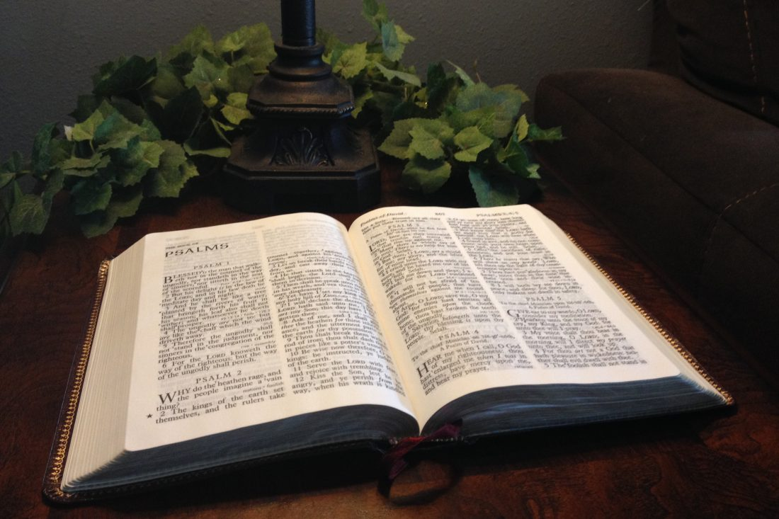
The Bible revolves around the Jews' captivity in Babylon (586 BC to 539 BC), sometimes called the Babylonian Exile, as a “type” or “foreshadowing” of God’s salvation of us in Jesus Christ.
Biblical prophets are classified by when they lived in relation to the Babylonian Exile.
- Pre-Exilic (before the Exile) – Message: Expressions of alarm about sins leading to captivity. Elijah, Elisha, Jonah, Amos, Hosea, Micah, Isaiah, Nahum, Zephaniah, and Habakkuk.
- Exilic (during the Exile) – Message: Encouragements to trust God to deliver from captivity. Jeremiah, Ezekiel, and Daniel
- Post-exilic (after the Exile) – Message: Exhortations to live lives devoted to the God who saves. Obadiah, Haggai, Zechariah, Joel, and Malachi
The Book of Isaiah is a miniature Bible in one book.
Isaiah 1-39 are pre-exilic warnings about sin; Isaiah 40-55 are exilic encouragements to trust God to deliver His people; and Chapters 56-66 are post-exilic exhortations to live lives devoted to God.
Isaiah is the First Gospel book of the Bible.
Matthew, Mark, Luke, and John follow the structure of Isaiah: Warnings, Encouragements, then Exhortations
The New Testament Pauline, Peter, and Johan Epistles are like the post-exilic exhortations of post-exilic prophets.
And then, of course, Revelation completes what started in Genesis!
Jesus conquers Babylon. His Kingdom shall not fail to bring mystery Babylon down.

Only Three Times the Finger of God Writes

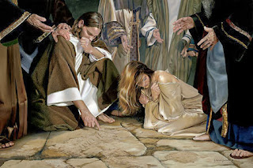
There are only three times in Scripture where we are told God writes with His finger.
- On Mt. Sinai, He wrote the Law on stone tablets with His finger (Exodus 34:1).
- In Daniel 5, God wrote with His Hand, "Mene, Mene, Tekel, Upharsin."
- The third time God's finger writes with His Hand is when Jesus kneels and writes on the dirt floor of the Temple in Jerusalem (John 8) when an adulterous woman is about to be stoned by religious leaders.
- The first time God writes, He gives us His demands (Law).
- The second time God writes, He sends His judgment for rebellion against His Laws (death), and
- On the third occasion, He graciously brings deliverance to the adulterous woman from both sin and death.
You know the story. A woman "caught in adultery" is brought before Jesus at the Temple.
The Pharisees know that the Law says that an adulterous woman is to be stoned (by the way, they are correct). The religious leaders test Jesus and ask Him what they should do with the woman.
Jesus remains silent but bends down and writes with his finger in the dirt.
One by one, the Pharisees leave, and Jesus is alone with the sinful woman.
Then Jesus straightened up and asked her:
'Where are your accusers? Has no one condemned you?"
“No one, sir,” she said.
“Then neither do I condemn you,” Jesus declared. “Go now and leave your life of sin.”
Jesus, as the Lawgiver, can alone forgive Lawbreakers or rebels (those in Babylon).
The entire theme of the Bible is God's grace through the Anointed One, redeeming, regenerating, and restoring sinners.
Grace doesn't just atone for sins; grace radically transforms sinners. The evidence of God's grace in one's life is the desire to go and "sin no more."
It is astonishing to see the parallels between historical Babylon in Daniel 5 (Daniel’s writings) and mystical Babylon in John 8 and Revelation 19 (John’s writings).
- Both historical and mystical Babylon had the Hand of God writing something.
- Both historical and mystical Babylon had two sinners in the presence of God.
- Both historical and mystical Babylon had the Temple's candlestick (the Spirit).
- Both historical and mystical Babylon had adulterous people redeemed (the Jews and the adulterous woman).
Yet, Belshazzar, king of Babylon, died in condemnation.
Belshazzar died loving Babylon. The Jews and the adulterous woman were released from Babylon.
What made the difference?
God did.
D. Martin-Lloyd Jones used to say, “The two most powerful words in the Bible are “But God…”
We all lived our lives by the lusts of our flesh, fulfilling the desires of the flesh and the mind, and were, by nature, children of wrath (e.g., “captives of mystery Babylon), just like everyone else.
But God…” - Ephesians 2:3-4.
The Apostle Paul describes to the Ephesian Christians God's work delivering them from their captivity in “mystery Babylon.”
“But God, who is rich in mercy, because of His great love with which He loved us, even when we were dead in our sins (e.g., captives in Babylon), has made us alive in Christ … that in the eons to come He might show us the exceeding riches of His grace in His kindness toward us in Messiah Jesus. By grace you’ve been delivered (e.g., from mystery Babylon) through faith in Him, and that not of yourselves; it is the gift of God, not of works, lest anyone should boast” – Ephesians 2:4-9
Principle #10: Live your life grateful for God’s powerful grace in delivering you from your sins.
Now you know why Babylon is so important in the Bible. It’s your testimony of how King Jesus conquered your Babylonian-loving heart.



If you enjoyed this explanation of Babylon in the Bible, consider subscribing to Wade Burleson at Istoria Ministries on Substack.

To share this PDF with others, CLICK HERE for the Link to share this post via social media or email.

Thank you for your support of Istoria Ministries!

Wade and Rachelle Burleson

801 South Van Buren Ave.

Enid, Oklahoma, 723703

Istoria Ministries – “Sharing His Story so that He becomes the Center of All Our Stories.”


Rachelle and Wade Burleson, Istoria Ministries

